The IL Pathways to Health logo is to be used on all your marketing materials as a requirement of working under AgeOptions license. Below are copies of the IL Pathways to Health logo for you to please use on all your marketing materials. If you have any questions, please contact the Health Promotion Team at (800)383-0258 or email ilpthreferral@ageoptions.org Thank you!

JPG-

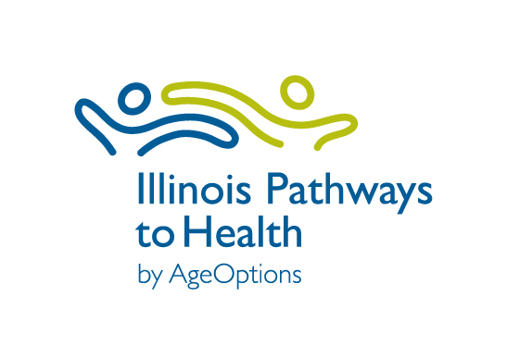

PNG- This has been created with a transparent background for maximum usage flexibility. This is good to use if you have a colored background.

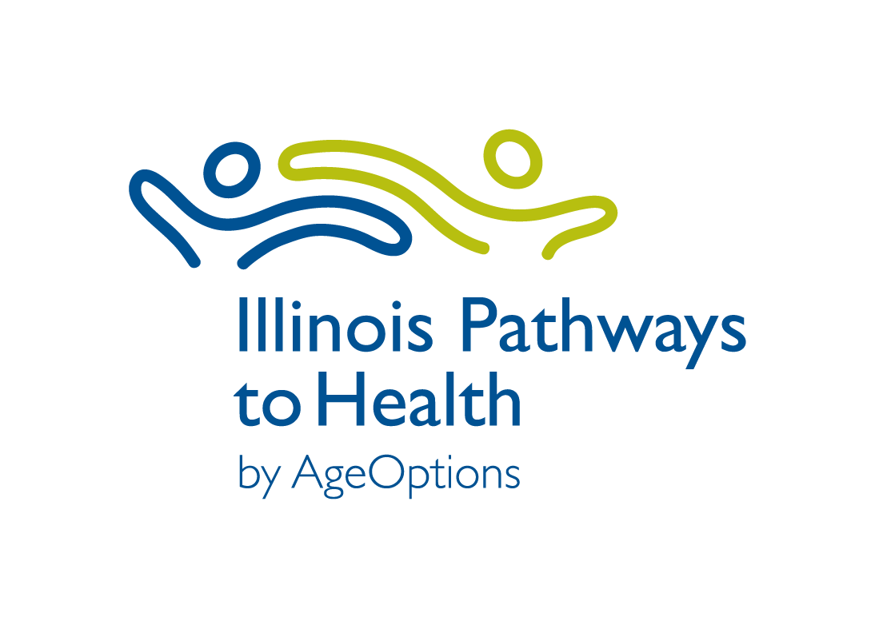

PNG Reverse- *The logo appears white so you will NOT be able to see it in the box below. It is outlined in black so you can see where the image is.

*This reverse logo is able to be used on colored backgrounds. For example:

